Task 1: Repository Setup & First Branch
- Create a new GitHub repository.
- Clone the repository to your local machine using SSH (generate an SSH key if needed, and add the public key to your GitHub account).
- Create a new branch named after your username (e.g., Tutedude).
- Add your Flask project files to this branch.
- Commit the changes and merge the branch into the main branch.

ANS :

Created a repo on github :

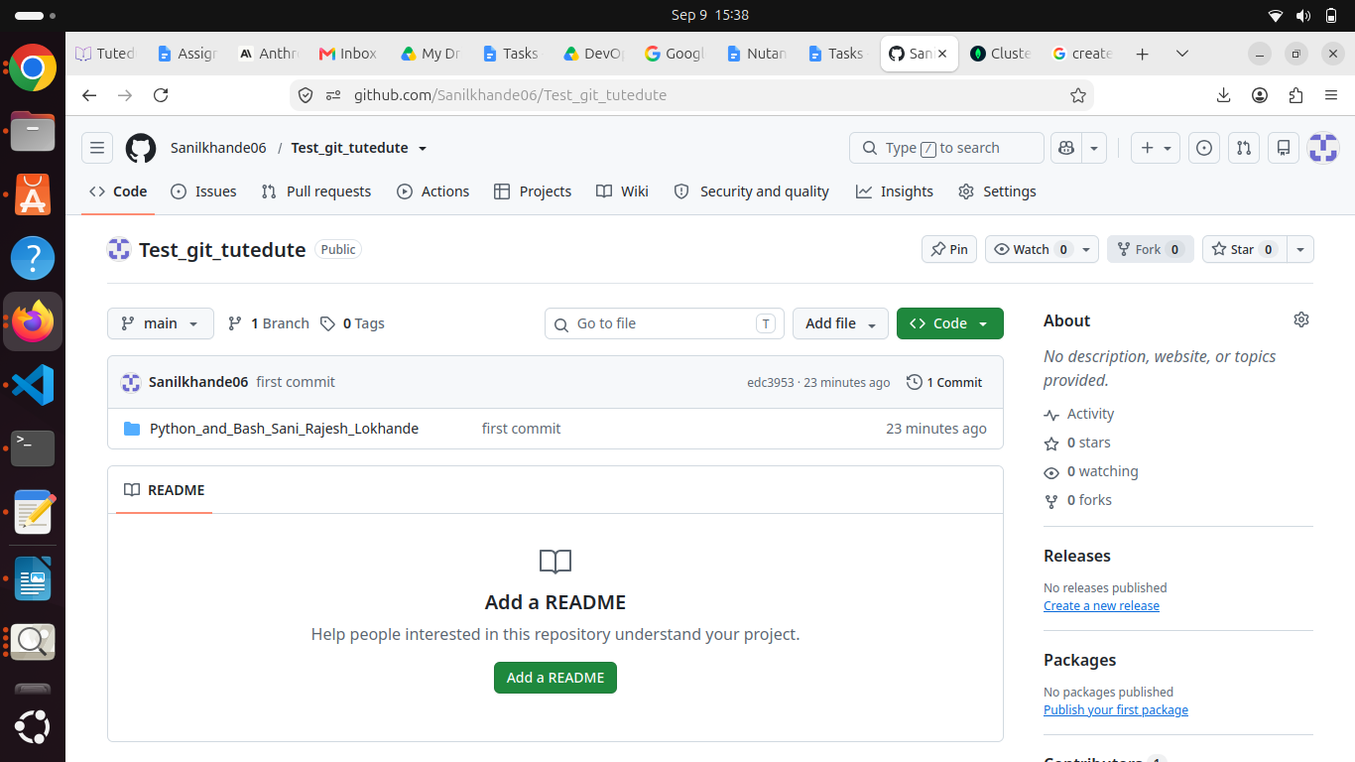

Created the ssh keys and updated it to github and cloned the repo

git clone is used to clone the repo

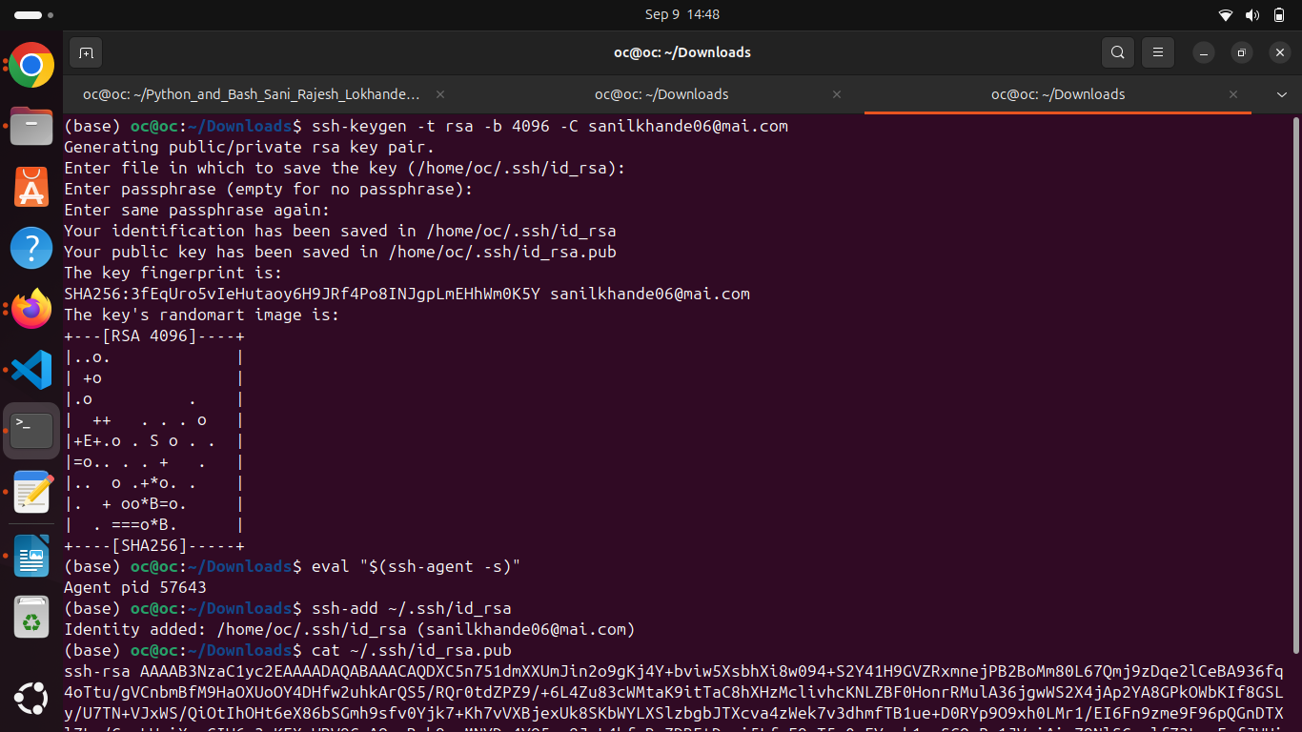

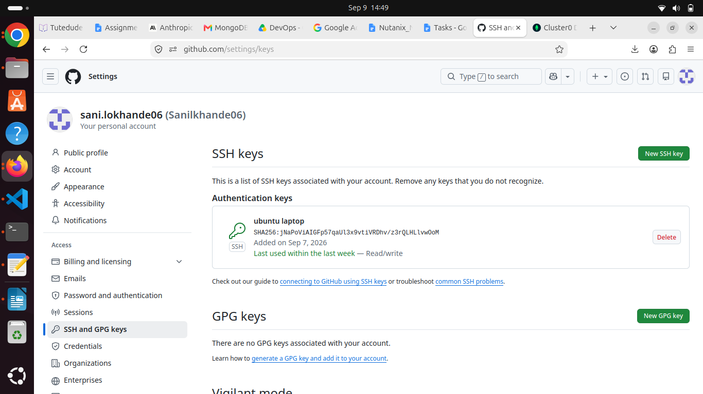

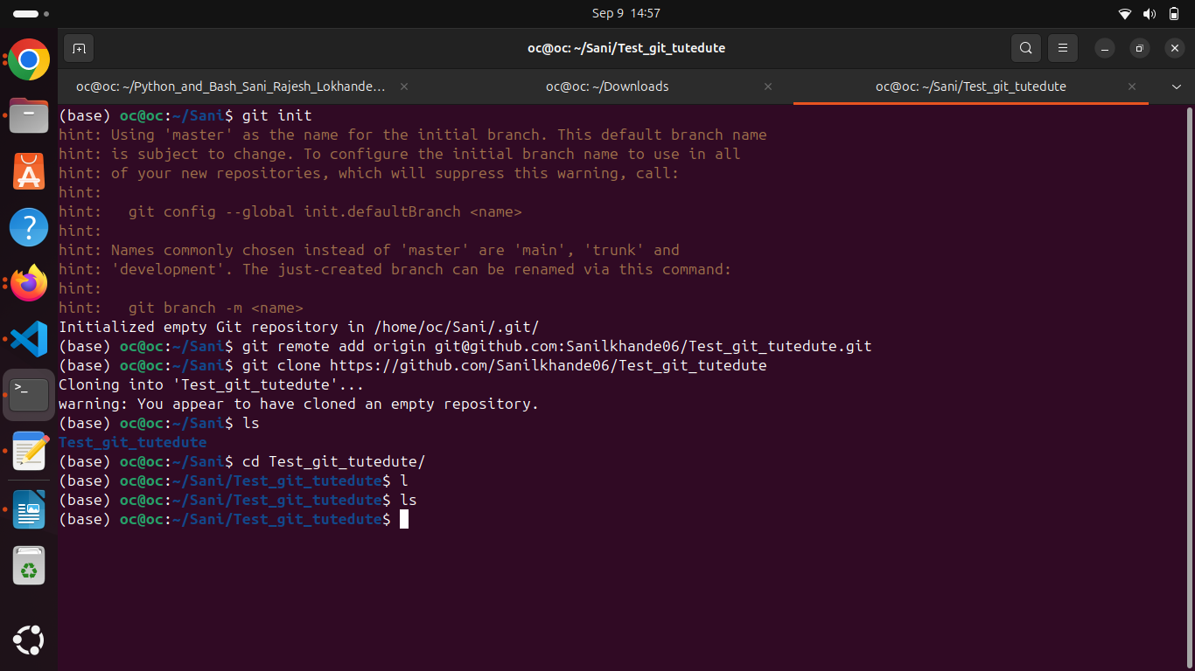

Create a new branch and Added the Flask project files to this branch.
Git branch “branch name” : command creates a new branch
git checkout “branch name”: switched to another branch
cp : copy file from source to dest. -r if copy a directory
git add . : staged all files copied and git commit to commit the all staged files

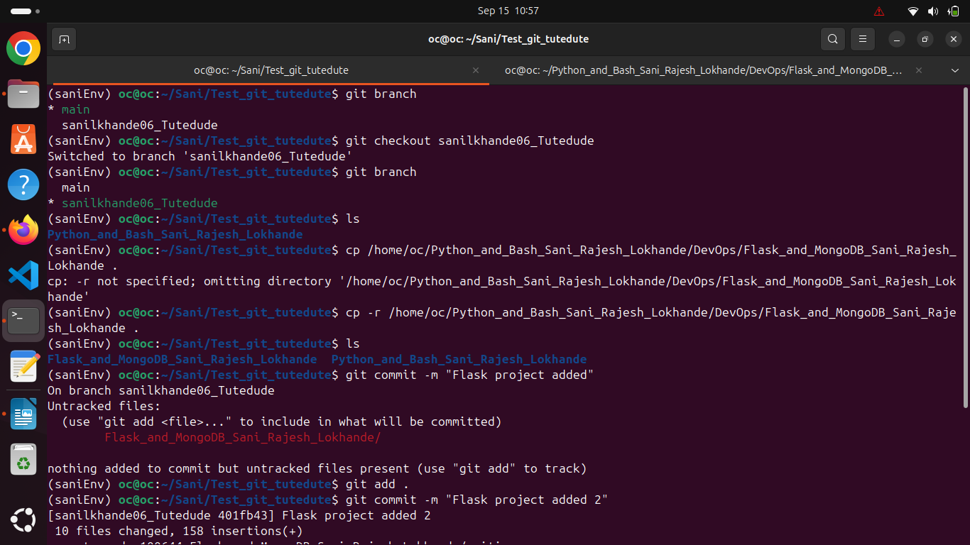

Commit the changes and merge the branch into the main branch.
Git merge is used to merge branch to main branch
